//Customer Search

//          Customer Id

// this does not need solr

select customer_id,full_name

from bank.customer

where customer_id = '1084545';

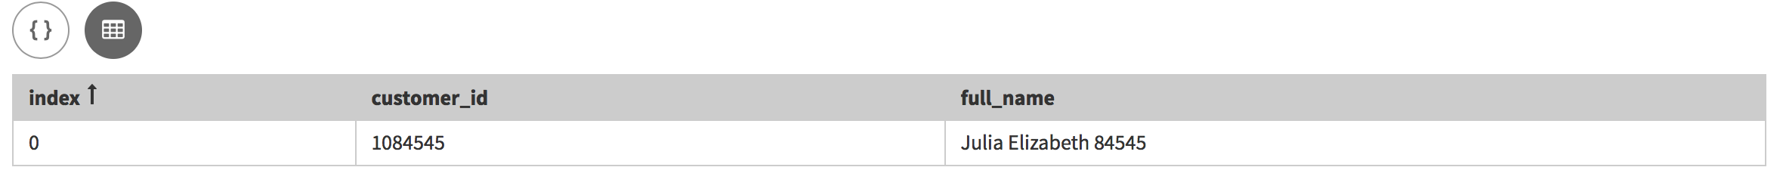 //-          Customer First Name, Last Name (full,  partial, wildcard)

//

select customer_id,full_name

from bank.customer

where solr_query = 'first_name:Jason';

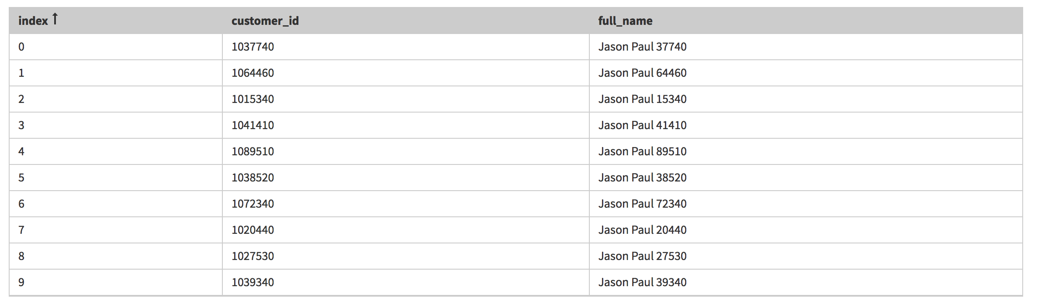

// last_name partial

select customer_id,full_name

from bank.customer

where solr_query = 'last_name:8454*';

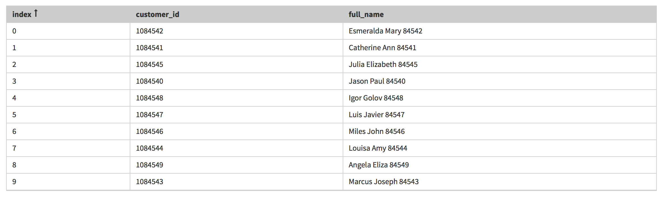

//-          Government Id (SSN, Tax Id)

select customer_id,full_name,government_id, email_address

from bank.customer

where solr_query = 'government_id:*4545';

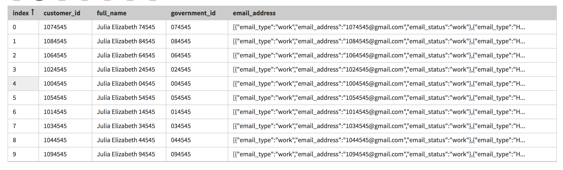

//-         full_name partial with leading wild card

select customer_id,full_name,government_id, first_name

from bank.customer

where solr_query = 'full_name:*4545';

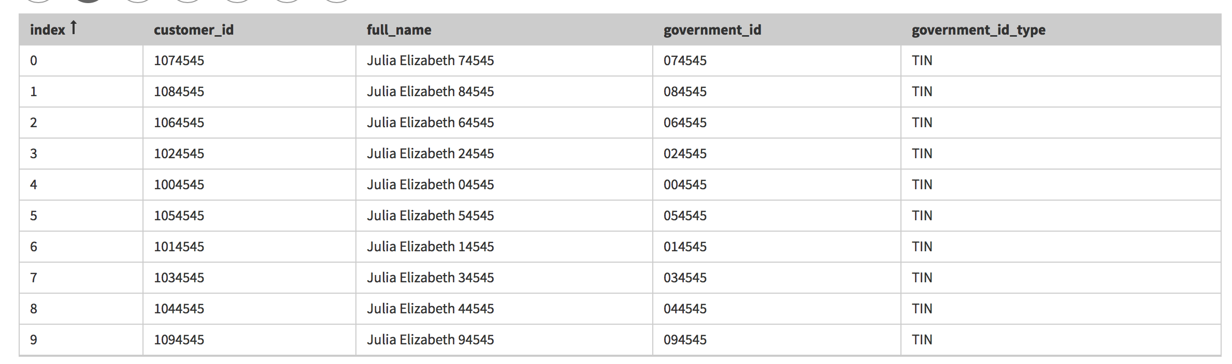

//-          Email (against collection)

select customer_id,full_name,email_address,phone_numbers

from bank.customer

where solr_query = '{!tuple}email_address.email_address:*24541';

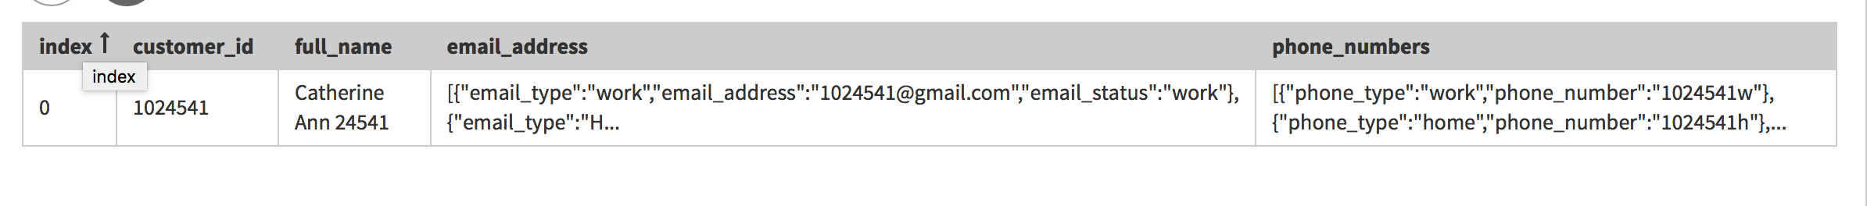

//-          Phone Number (against collection)

select customer_id,full_name,phone_numbers

from bank.customer

where solr_query = '{!tuple}phone_numbers.phone_number:*14540h';



//-          Address (wildcard)

select customer_id,full_name,address_line1,address_line2,city,state_abbreviation,zipcode

from bank.customer

where solr_query = 'address_line1:*14543';



//-          Multi-field search (partial name and Phone)

select customer_id,full_name,phone_numbers

from bank.customer

where solr_query = 'full_name:Jason* AND {!tuple}phone_numbers.phone_number:*14540w';



//-          customer accounts in customer

select customer_id,custaccounts

from bank.customer

where solr_query = 'custaccounts:"44ba4d82-6f5b-4381-9f3e-ccee0e89099f"';

